**WEEK-1: Engineering Concepts**

**Designs and Patterns**

**Exercise 1: Implementing the Singleton Pattern**

**1.Logger.java:**

public class Logger{

    private static Logger instance;

    private Logger(){

        System.out.println("Logger initialized.");

    }

    public static Logger getInstance(){

        if (instance == null) {

            instance = new Logger();

        }

        return instance;

    }

    public void log(String message) {

        System.out.println("[LOG]: " + message);

    } }

**2.TestLogger.java:**

public class TestLogger{

    public static void main(String[] args){

        Logger logger1 = Logger.getInstance();

        logger1.log("First");

        Logger logger2 = Logger.getInstance();

        logger2.log("Second");

        if (logger1 == logger2){

            System.out.println("Both instances are same, Singleton");

        }else{

            System.out.println("Different");

        }

    }

}

Output:

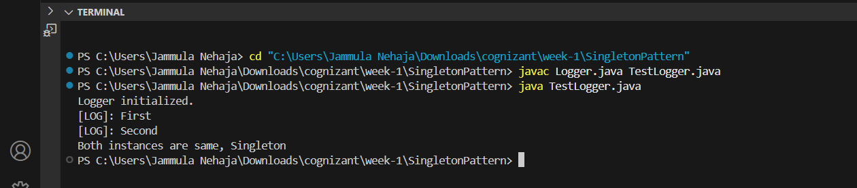

**Exercise 2: Implementing the Factory Method Pattern**

1.Document.java:

public interface Document{

    void open();

}

2.WordDoc.java:

public class WordDoc implements Document {

    public void open(){

        System.out.println("Opening word");

    }

}

3.Pdf.java:

public class Pdf implements Document{

    public void open(){

        System.out.println("Opening pdf");

    }

}

4.Excel.java:

public class Excel implements Document {

    public void open(){

        System.out.println("Opening Excel");

    }

}

5.DocFact.java:

public abstract class DocFact{

    public abstract Document createDoc();

}

6.WordFact.java:

public class WordFact extends DocFact{

    public Document createDoc(){

        return new WordDoc();

    }

}

7.pdfFact.java:

public class pdfFact extends DocFact {

    public Document createDoc() {

        return new Pdf();

    }

}

8.ExcelFact.java:

public class pdfFact extends DocFact {

    public Document createDoc() {

        return new Pdf();

    }

}

9.TestFact.java:

public class TestFact {

    public static void main(String[] args){

        DocFact wfact=new WordFact();

        Document wrd=wfact.createDoc();

        wrd.open();

        DocFact pfact=new pdfFact();

        Document pdf=pfact.createDoc();

        pdf.open();

        DocFact exc=new ExcelFact();

        Document excl=exc.createDoc();

        excl.open();

    }

}

Output:

